Exchange Service Application Documentation

**User Story 1: Loading data into database**

As per the given requirement, when ever the user communicates with the application endpoint, the system must fetch the data from the **Rates API** for last 12 months from either current date or the provided input date and store them into in-memory database. Please find the attached screenshot for your reference.

**Communication with Rates API using Rest Template:**

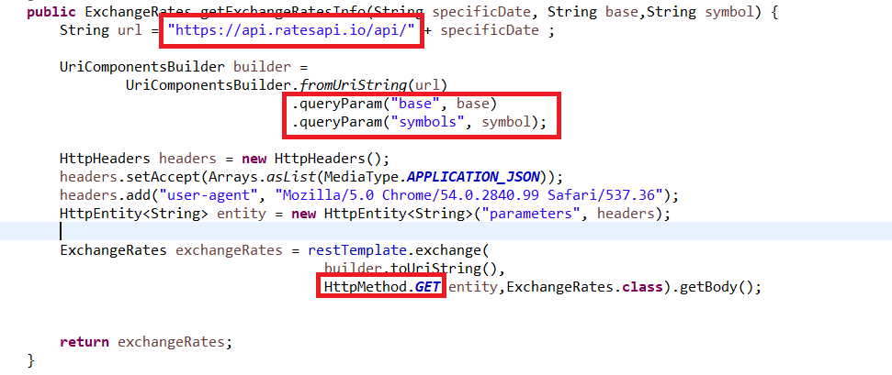

**Request:**

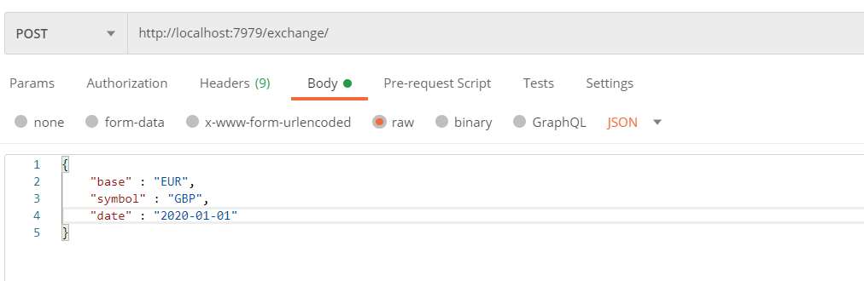

**Response:**

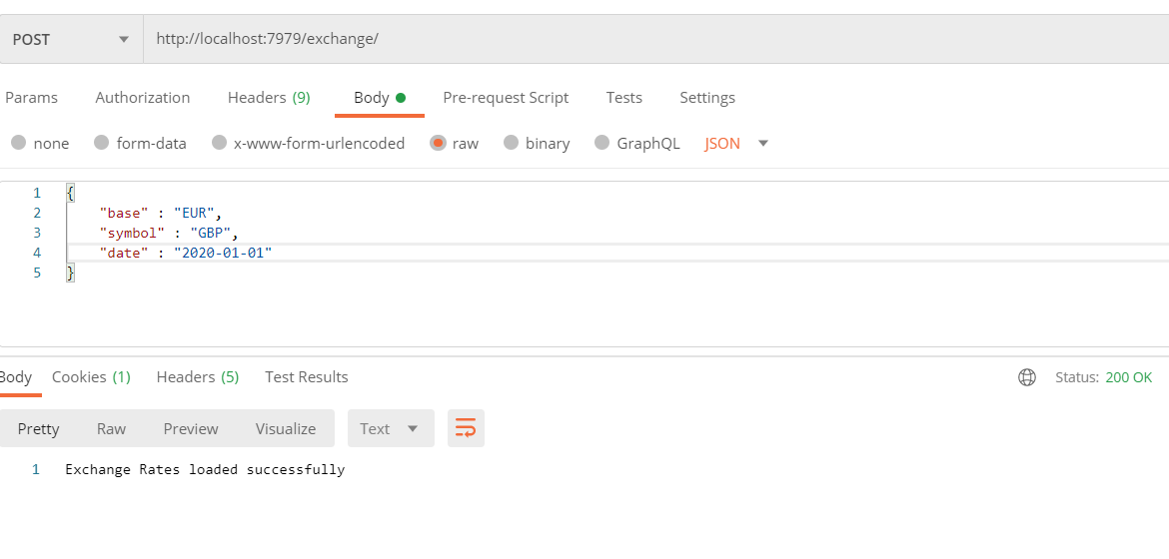

**In-memory Database:**

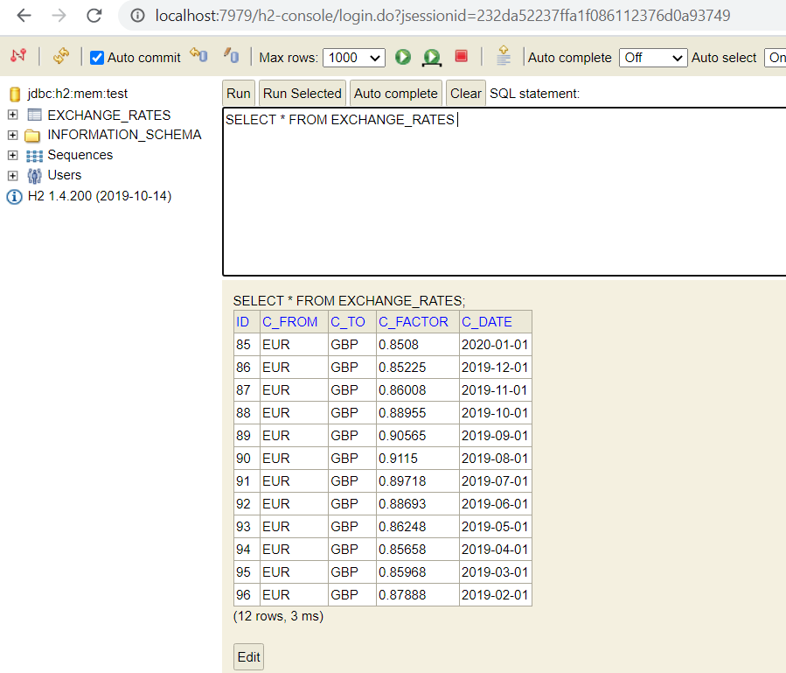

Whenever the user performs the above request (POST), the data will be automatically deleted from the table and reload the information associated to the provided details.

**Data comparison with Rates API:**

**GBP** to **EUR** Exchange Rate on **2019-05-01** is 0.86248

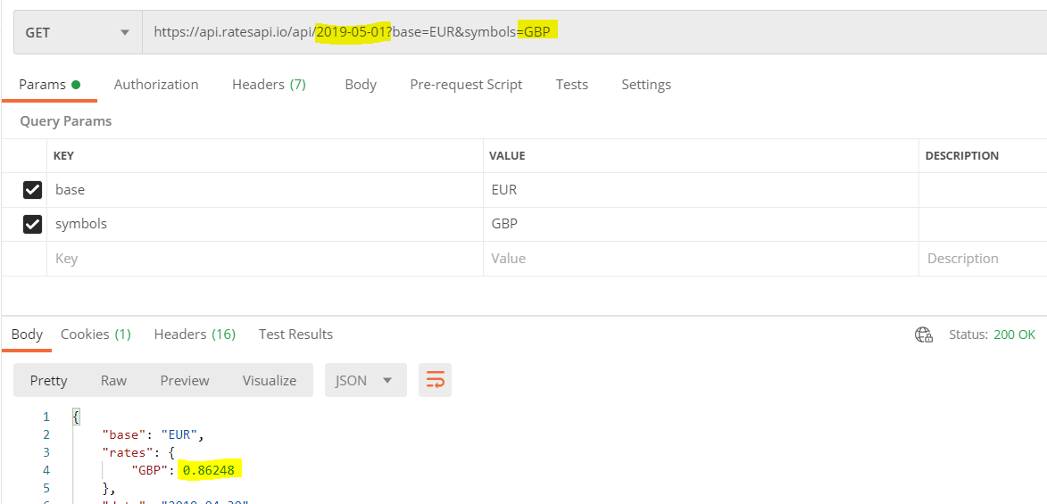

**In-memory Database:**

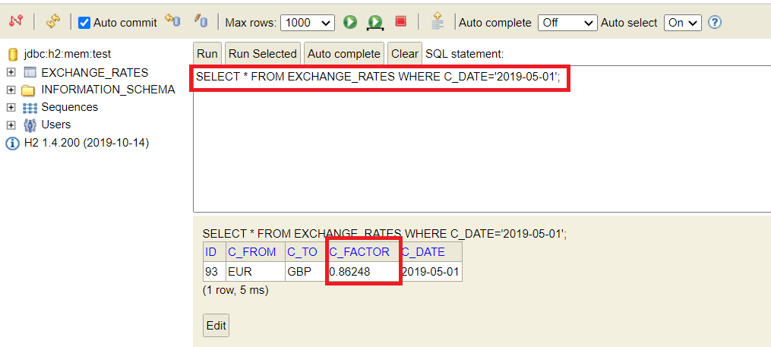

The exchange application supports only the requests with exchange symbol **USD/GBP/HKD.** If the user provides other information in the request for loading data, the system will display the following message.

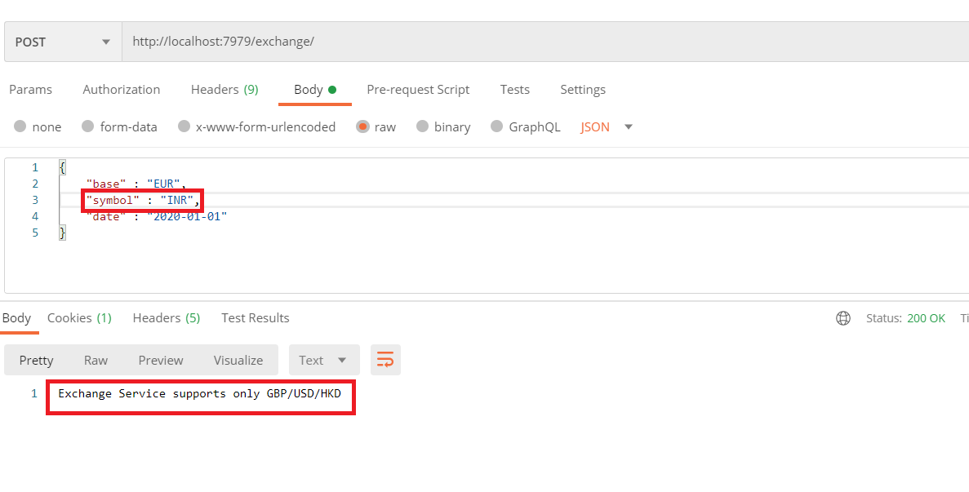

**Note**: By default, base will be **EUR** and symbol will be **GBP** and date will be the **current date**.

**User Story 2: Exposing data**

As per the given requirement, whenever the user communicates to the application endpoint it has to fetch the data from the in-memory database and display the details to the user.

**Get Exchange Information Between Date Range:**

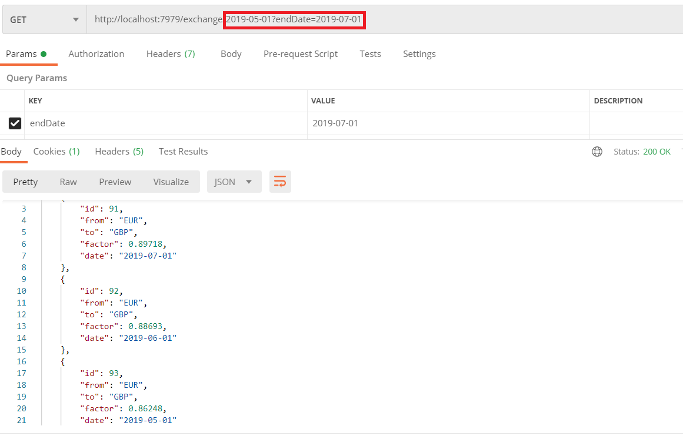

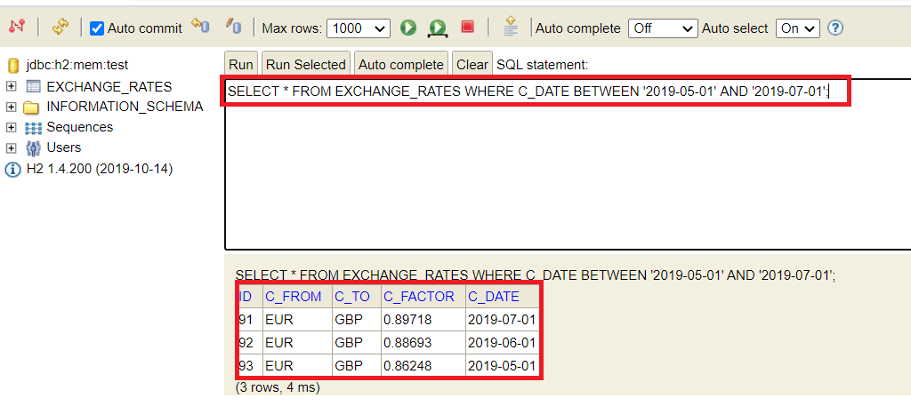

Whenever the user provides only single date in the request URL, the application will fetch on the details associated or matching to that date only. Please find the below screenshot for your reference.

